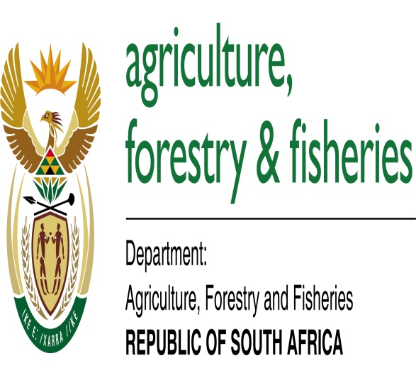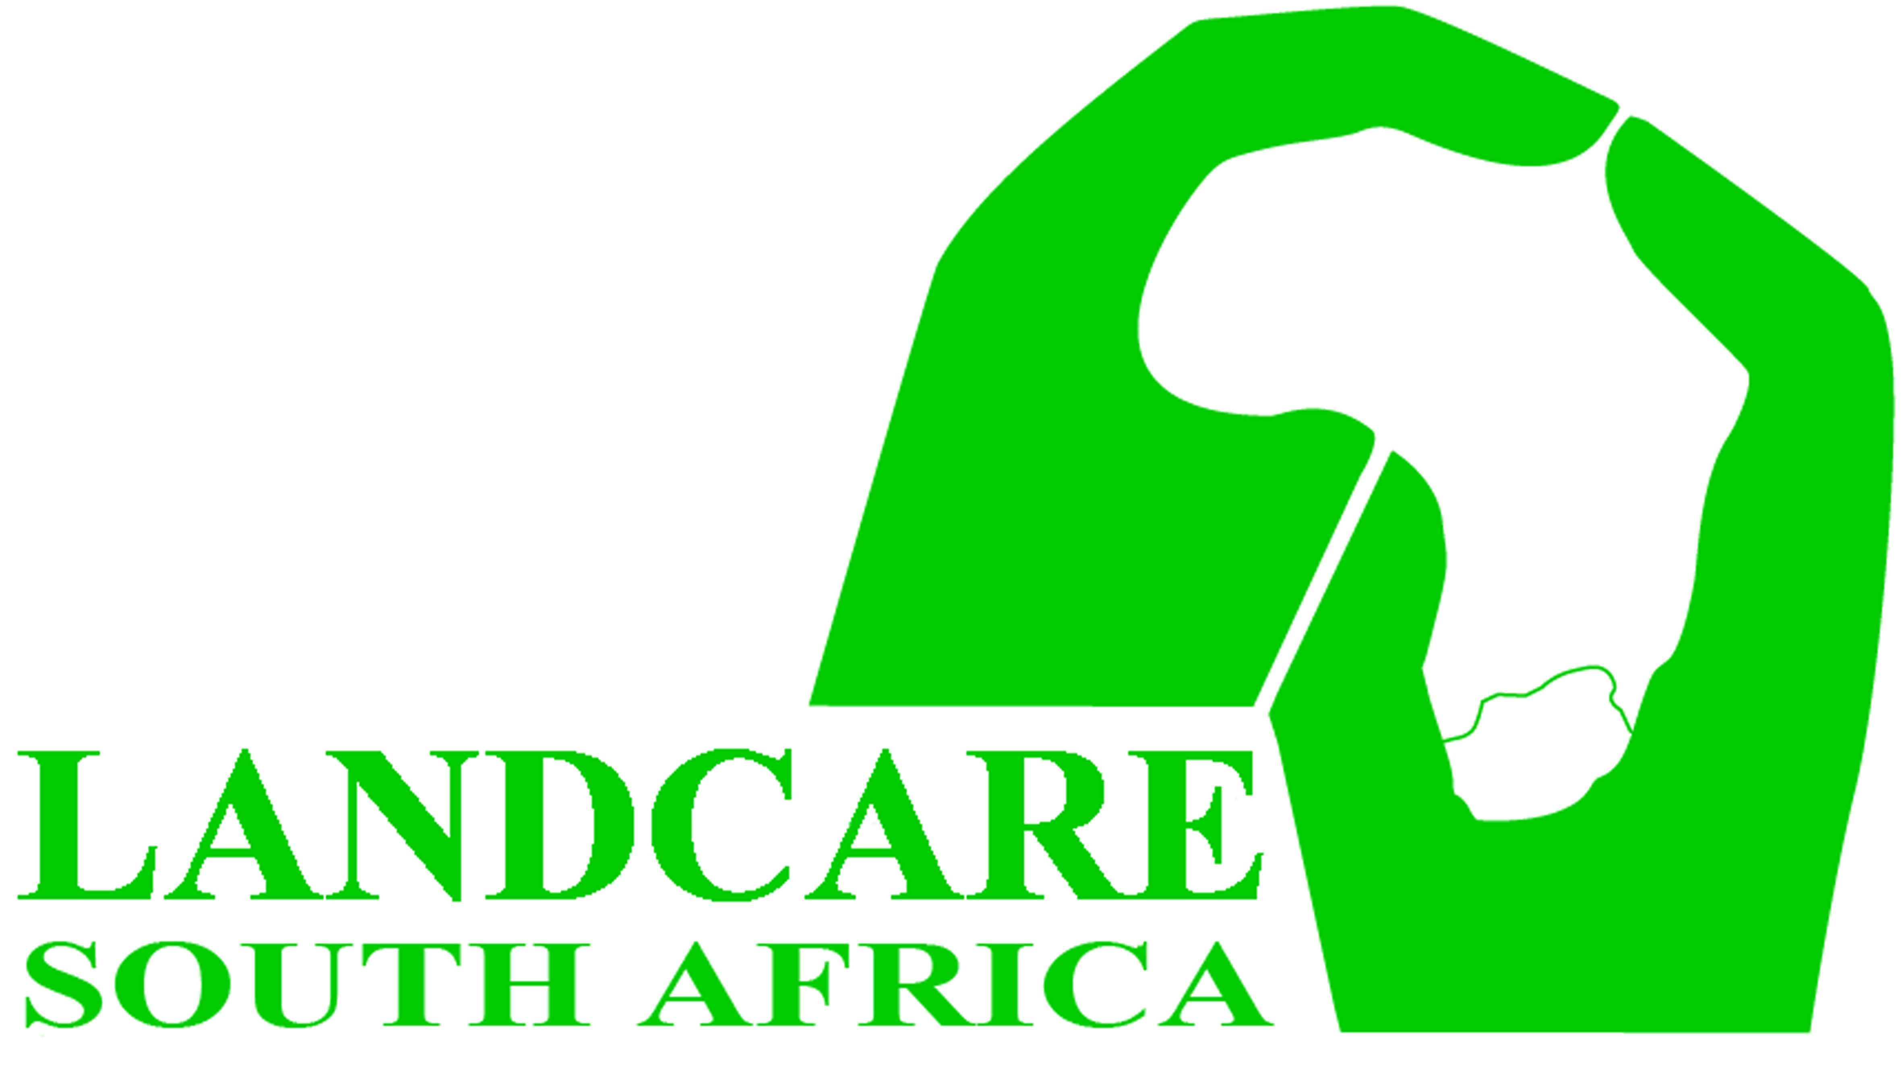

Steynsrus Slangbos LandCare Project

Steynsrus is a small farming town in the Free State Province. It is falls under the Moqhaka Local Municipality and is administered from Kroonstad. Steynsrus is located on the R76 and R720 road between Kroonstad and Senekal, roughly 50 km from both. A LandCare committee was established in Steynsrus with huge success. The Department of Agriculture, Forestry and Fisheries in partnership with the Free State government, led by the Provincial Department of Agriculture and Rural Development, established this LandCare project in the 2011/12 financial year to engage environmental challenges faced by the community. The LandCare committee ensures commitment, involvement, debate, transparency and awareness. Most important about the committee is that it ensures that all the projects in the area are community-based and it is empowering local people to take decision about their own problems. The LandCare committee ensures commitment, involvement, debate, transparency and awareness. The project is addressing the emerging farmers in the district’s problems by combating invader plants on their farms. Addressing the causes, rather than the effects, is high on the priority list as rehabilitation can be very expensive. The LandCare Conditional Grant has managed to contribute R450 000 since the project’s initiation. 25 people were employed by the LandCare project for a total of 84 days for the 2015/16 cycle of this project: two men, 23 women and also 16 youths. An additional 11 people were employed by EPWP funding, including one man and six women for a total of 76 days. 25 people were employed by the LandCare project for a total of 84 days for the 2017/18 cycle of this project: two men, 23 women and 16 youths as well.

Before
